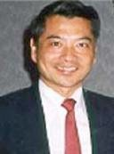 **IPR and Applications to e-Forensics and Smart Cities**

Prof. Patrick S.P. Wang, ***Fellow, IAPR, ISIBM & IETI and IEEE ISIBM Outstanding Achievement Awardee***

Professor of Computer and Information Science Northeastern University, Boston, MA, USA

MIT, Harvard University, USA, Zijiang Visiting Chair, ECNU, Shanghai, China

iCORE Visiting Professor, University of Calgary, Canada Otto-von-Guericke Distinguished Guest Professor, University Magdeburg, Germany

Founding Editor-in-Chief, IJPRAI and MPAI Book Series, WSP

**Intelligent Pattern Recognition (IPR) and Applications to Imaging**

### --- Security, Safer Transportation, Robotics, Biometrics, and Better Interactive Learning Environment

Prof. Patrick S.P. Wang, Ph.D., ***Fellow, IAPR, ISIBM, WASE, IETI Distinguished Fellow 傑出院士***

Northeastern University, Boston, ECNU, Shanghai, MIT and Harvard, USA [patwang@ieee.org](mailto:patwang@ieee.org)

#### Abstract:

This talk is concerned with fundamental aspects of Intelligent Pattern Recognition (IPR) and applications. It basically includes the following: Basic Concept of Automata, Grammars, Trees, Graphs and Languages. Ambiguity and its Importance, Brief Overview of Artificial Intelligence (AI), Brief Overview of Pattern Recognition (PR), What is Intelligent Pattern Recognition (IPR)?

Interactive Pattern Recognition Concept, Importance of Measurement and Ambiguity, How it works, Modeling and Simulation, Basic Principles and Applications to Computer Vision, Security, e-Forensics, Road Sign Design, biomedical diagnosis, Safer biomedical diagnosis, Traffic and Robot Driving with Vision, Ambiguous (design of Road Signs vs Unambiguous (Good) Road Signs, How to Disambiguate an Ambiguous Road Sign? What is Big Data? and more Examples and Applications of Learning and Greener World using Computer Vision. Finally, some future research directions are discussed.

#### Intended Audience:

Scientists and engineers, with some computer science, artificial intelligence, pattern recognition, and/or image processing background or working experience.

#### Why this topic would be of interest to a substantial part of the audience:

Attendees can learn basic concept of “biometrics”, which is of growing interest and importance in recent years, and its applications in many fields, including engineering, scientific experiments, bio- medical imaging, pattern recognition, and homeland national security.

**Length of the talk**: 1 hour keynote, 3 hours tutorial, or seminar sequence

#### Evidence of teaching experience and evidence of scholarship in the area:

##### Preliminary versions of this talk have been successfully presented in various international conferences, and have received warm responses, including: CISCYN2013, Madrid, Spain, 2013, AMS2013, Hong Kong, 2013, MLDM 2013, WIPRA2013, New York, USA,

ICCI2013, Chengdu, China, UKSim2014, Cambridge, UK, 2014, WCSC2014, U C

Berkeley, USA, 2014, AMS2014. Taipei, Taiwan, and ICCI2014, Kunming, China.

1

[http://icprai2018.com](http://icprai2018.com/) (2018, Montreal, Canada) <http://icmmi.polsl.pl/pa> ges/keynote_speakers, 2017, Poland,

<http://www.mda-signals.de/invited_talks.php>,

2016, USA

<http://www.icgip.org/keynote.html,> 2015, China <http://www.uksim.info/uksim2014/uksim2014.htm>

(2014, Cambridge, UK)

<http://www.wconsc-2014-berkeley.com/keynote.html> (2014, U.C. Berkeley, USA) <http://www.icbfe.org/keynote.html>, Singapore, 2013

#### Brief Biography of the Presenter

**Prof. Patrick S.P. Wang, PhD**. ***Fellow, IAPR, ISIBM, IETI*** and ***IEEE & ISIBM Outstanding***

***Achievement Awardee,*** Tenured Full Professor, Northeastern University, USA, iCORE (Informatics Circle of Research Excellence) Visiting Professor, MIT, Harvard, University of Calgary, Canada, Otto-Von- Guericke Distinguished Guest Professor, Magdeburg University, Germany, Zijiang Visiting Chair, ECNU, Shanghai, China, as well as honorary advisory professor of many key universities in China, including Sichuan University, Xiamen University, East China Normal University, Shanghai, and Guangxi Normal University, Guilin.

Prof. Wang received his BSEE from National Chiao

Tung University (Jiaotong University), MSEE from

National Taiwan University, MSICS from Georgia

Institute of Tech, and PhD, CS, Oregon State U.

Dr. Wang has published over 26 books, 300 technical papers, 3 USA/European Patents, in PR/AI/TV/Cybernetics/Imaging, and is currently founding Editor-in-Chief of ***IJPRAI (International Journal of Pattern Recognition and Artificial Intelligence)*** , and Book Series of ***MPAI***, WSP. In addition to his technical interests, Dr. Wang also published a prose book, “***Harvard Meditation Melody***”《哈佛冥想曲 》**,** 《劍橋狂想曲》and many articles and poems regarding Du Fu and Li Bai’s poems, Beethoven, Brahms, Mozart and Tchaikovsky’s symphonies, and Bizet, Verdi, Puccini and Rossini’s operas.

**For further details, please contact**:

Prof. Patrick S. Wang, Ph.D., Zijiang Visiting Chair, ECNU, Shanghai, China

***IEEE Outstanding Achievement Awardee IAPR Fellow*** and Co-Chief Editor, ***IJPRAI*** and MPAI Book Series, WSP

Northeastern University, Boston, MA ,USA (617)281-5345

[patwang@ieee.orgUH,](mailto:patwang@ieee.orgUH)

***IEEE Outstanding Achievement Awardee*** <http://ejournals.wspc.com.sg/ijprai/mkt/editori> al.shtmlUH, ***Founding Editor-in-Chief***

HU[http://www.worldscibooks.com](http://www.worldscibooks.com/)

/series/smpaiseries.shtml

UH

##### **Bibliography** (selected from over 300 technical papers and books)

##### [1] P.S.P.Wang, New Developments of AI, PR, CV & e-Forensics, MDA2019, New York, USA (Keynote)

##### [2] P.S.P.Wang, Hazy Image Database Analysis of the Frequency Magnitude,IJPRAI , July 2018 (with [Petra Perner](https://www.worldscientific.com/author/Perner%2C+Petra)) [3] P.S.P.Wang, Rank Factor Granules with Fuzzy Collaborative Clustering, IJPRAI , June 2017 (with S. Liu and F, Yu) [4]P.S.P.Wang, New Development of IPR and e-Forensics, Theories and Applications, Shanghai, China, November, 2016 [5]P.S.P.Wang, Intelligent Pattern Recognition and Big Data, ICGIP 2016, Tokyo, Japan, October, 2016 [6]P.S.P.Wang, IPR, Big Data, and Applications, ICCIS2015, Shenzhen University, December, 2015 [7]P.S.P.Wang, Similarity-Base AI and PR, Theory and Applications, WCSC2014, UC Berkeley, Keynote [8]P.S.P.Wang, Situational Awareness through Biometrics, with A. Poursaberi et al, IEEE-Computer May 2013 [9] P.S.P.Wang, A Review of Wave-based Edge Detection Methods for Image Understanding and Interpretation,with J. Yang , *Int. J. Pattern Recognition & Artificial Intelligence* (*IJPRAI)*, v26, n 8, (2012) [10] P.S.P.Wang, Anil K. Jain, Arun A. Ross, Patrick Flynn, Handbook of Biometrics, Springer Verlag, 2012 [11]P.S.P.Wang, Intelligent Pattern Recognition and Biometrics, Springer/HEP, 2011 [12]P.S.P.Wang, Pattern Recognition and Machine Vision, River Pub, Denmark, 2010 [13] P.S.P.Wang, “Concept of Ambiguity and Application to Security and Transportation Safety”, IEEE- ICSSE2010, (2010) [14] P.S.P.Wang,Object Recognition, <http://sites.google.com/site/mozart200/> (2009) [15]P.S.P.Wang, Pattern Recognition and Artificial Intelligence in Biometrics - EDITORIAL, S.N. Yanushkevich,D. Hurley, and P.S.P. Wang, *IJPRAI,* Vol. 22, No. 3, 367-369 (2008) [16]P.S.P.Wang and S. Yanushkevich, "Biometrics Technologies and Applications", *Proc. IASTED AIA2007* *(Artificial Intelligence Applications)*, Innsbruck, Austria, 2007, p226-231 (2007) [17]P.S.P.Wang, "Some Concerns on the Measurement for Biometrics Analysis and Applications", in“*Image Pattern Recognition - Synthesis and Analysis in Biometrics”* WSP, 2007 (ed)S.N. Yanuskevich, P.S.P.Wang, S.N. Srihari, and Marina Gavrilova). P321-337 (2007)

## Appendix: Some Highlighted Illustrations of the Presentation

**Robot walking and picking up package**

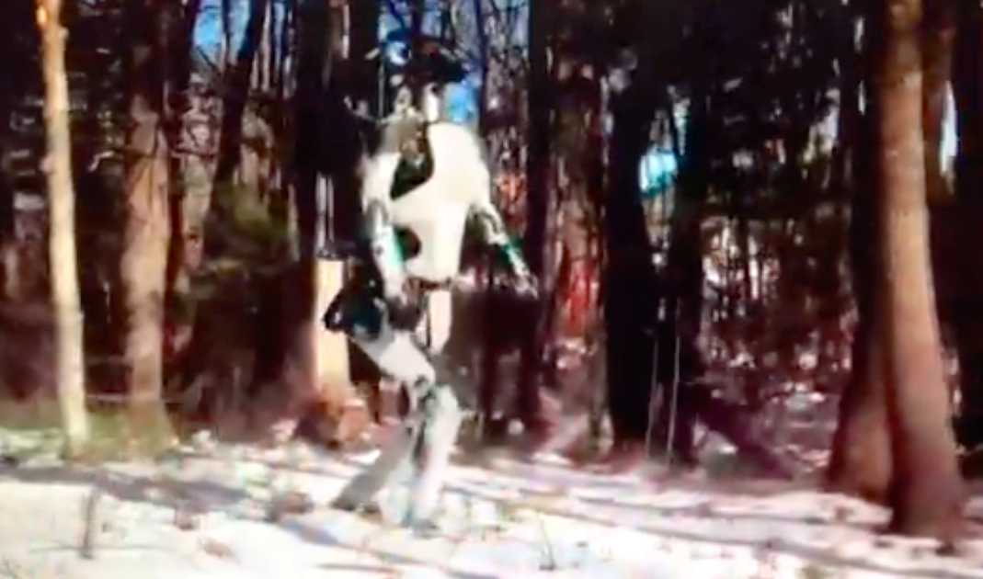

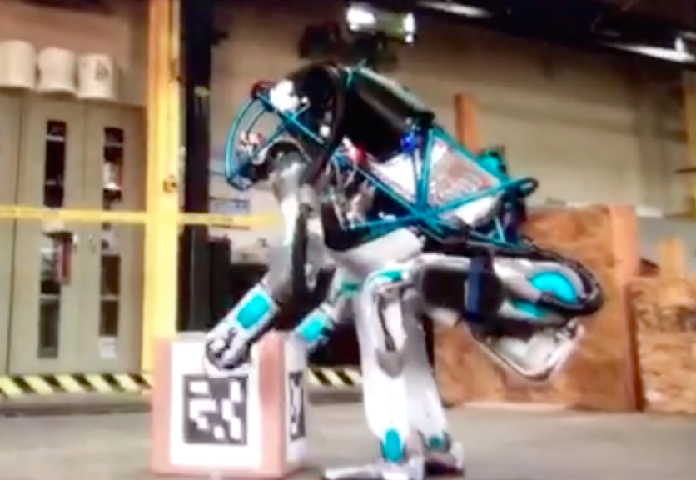

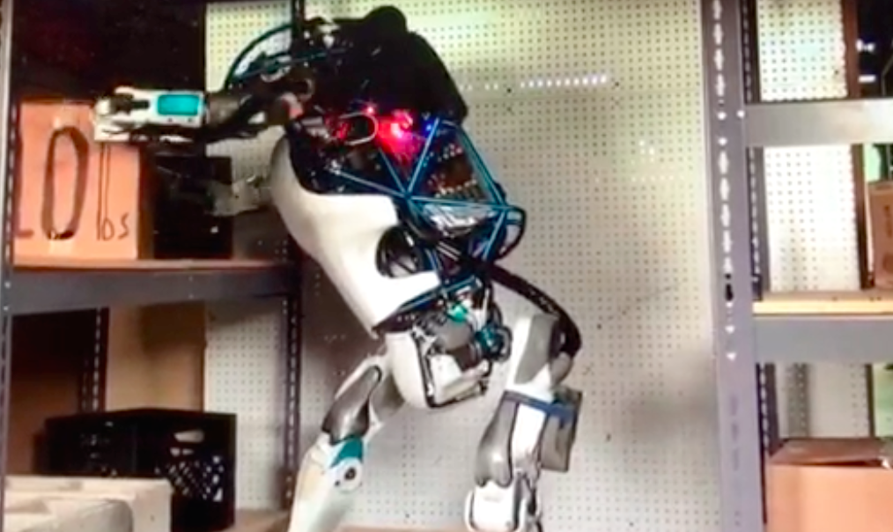

**Ambiguous and Dangerous Road Signs, need to be improved by Intelligent Pattern Recognition System**

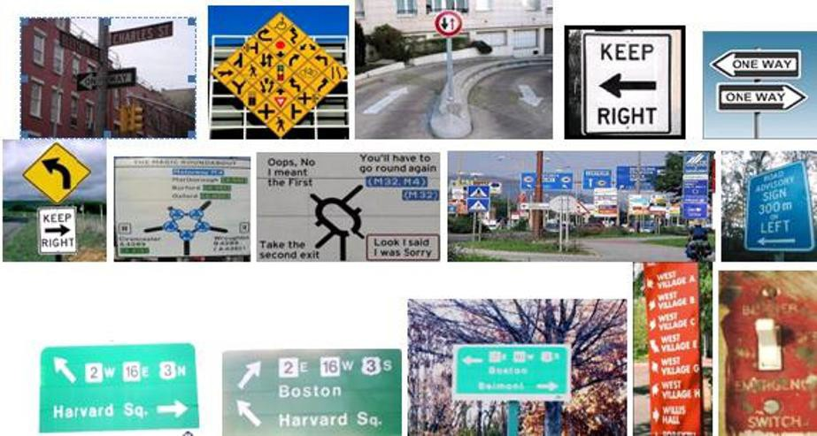

***An Example of Ambiguous Road Sign***

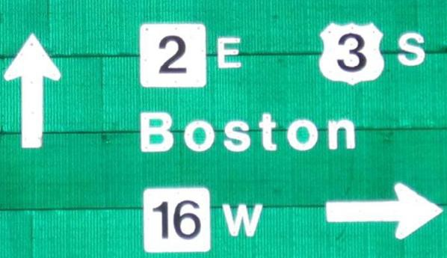

***An Illustration of Measurement Ambiguity***

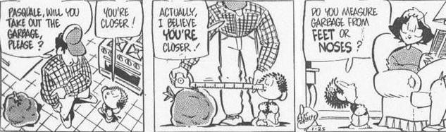

***Biomedical Imaging Diagnosis***

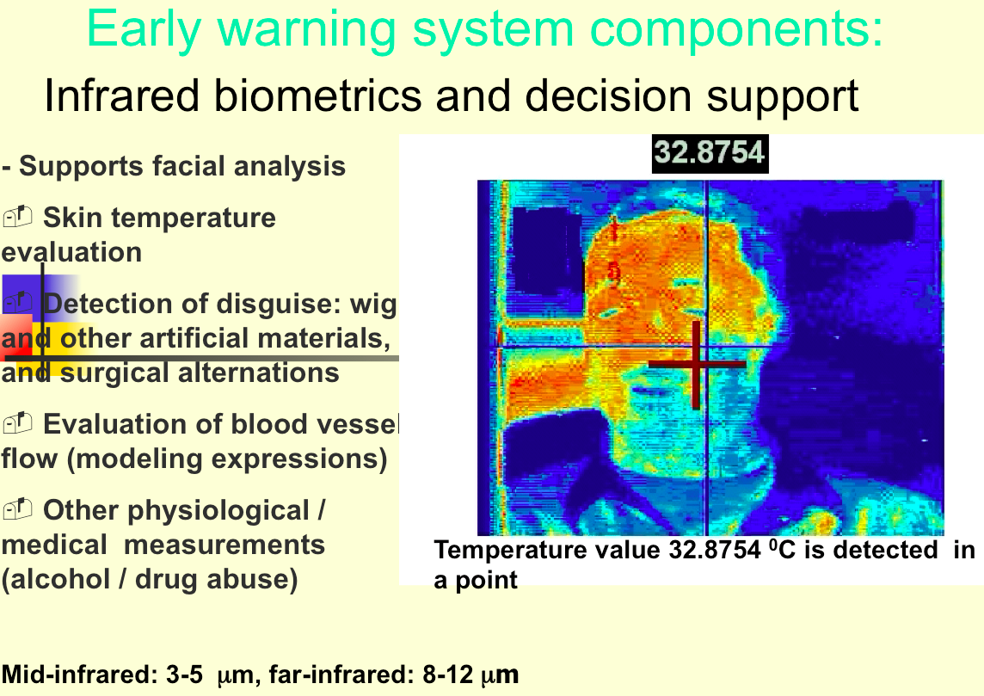

***Interactive Recognition System with Iterative Learning***

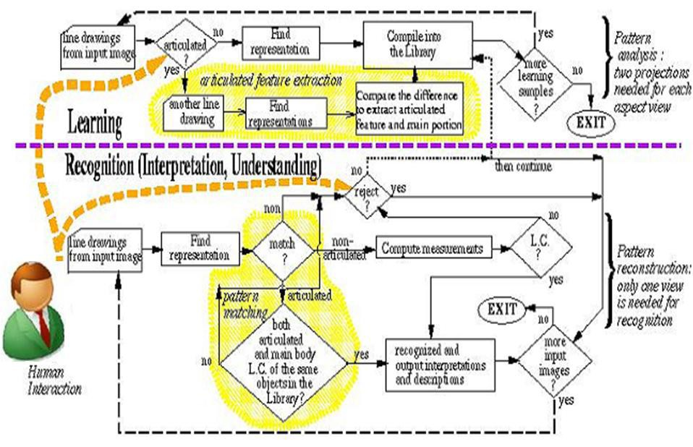

## 1,024 Gigabytes = 1 Terabyte.

**1,024 Terabytes = 1 Petabyte.**

**1,024 Petabytes = 1 Exabyte**

**(In 2000, 3 exabytes of information was created.) 1,024 Exabytes = 1 Zettabyte.**

**Big Data=> Also depends on complexity of problems**

## What is a terabyte? What is bigger than a terabyte? searchstorage.techtarget.com/answer/Whats-bigger-than-a- Terabyte

